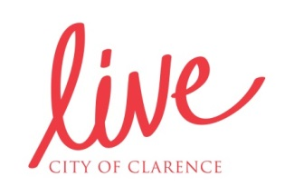
I CAN, YOU CAN, TOGETHER WE CAN
Help us celebrate the health and wellbeing achievements of the people of Clarence.
We’d like to hear from you as part of Council’s I Can, You Can, Together We Can campaign. Tell us about how you are achieving your health and wellbeing goals. These can be many and varied, such as doing some exercise, or participating in a social or interest group. It could be something small or something big. It could be the goals that you share with a friend or a group of like-minded people.
Help us celebrate the stories of people in our community who are making a difference to their own life by doing things to be well and healthy.
Here are a couple of stories as examples:
Candice
I’ve always been pretty active, but learned that I need to get my heart rate up a couple of times a week in order to be fit and healthy. I was a member at the local 24 hour gym and started to use the treadmill for a bit of running. I started to run further and go faster, using the machine’s settings as a challenge. Now I can run 5km and even went in the “Run the Bridge” fun run recently. Even when I was young I wouldn’t run that far, but am happy that I can in my 40s!
Jim
My wife and I retired, and after a bit of travel I found myself back home, lacking motivation and not leaving the house. I decided to do something about it and looked into doing some volunteering. Now I could spend all day every day doing things for others and am feeling much better for it!
To share your story please complete the section below and accompany it with a photo (a clear shot that features the person in action and if possible, looking at the camera) and send both this form and the photos to liveclarence@ccc.tas.gov.au. Alternatively, you can provide the text to us directly in the email.
□ Attached is a clear head shot / action shot of an individual or group
Name of person/s featured in photo:
Story of person/s featured (100 words or less):

Note: By submitting this story and photo you give permission for this content to be used for promotional purposes by Live Clarence and Clarence City Council. Photos and stories featuring people other than you must have the approval of these people for use by Live Clarence and Clarence City Council.
For queries please contact Council on 62179599 or 62179532

